Introduction
This write-up refers to the Stick machine If support is required, please open a ticket in the support channel on the Discord server..

Reconnaissance
Initially, a port scan was performed on the machine using RustScan and ports 22 and 80 were identified as open.

export IP=<ESIP_VPN>
rustscan -a $IP --ulimit 5000 -- -v -Pn -A

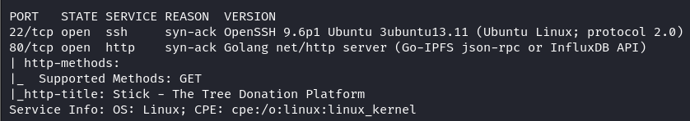
Figure 1 – Open ports on the machine

When accessing port 80, a web donation portal aimed at restoring global flora is displayed.

Figure 2 – Web portal interface
It is possible to create an account by clicking the Sign Up button in the upper-right corner. After creating an account and logging in, a message appears on the dashboard stating that if 1000 trees are planted, the user will be invited to become an administrator.

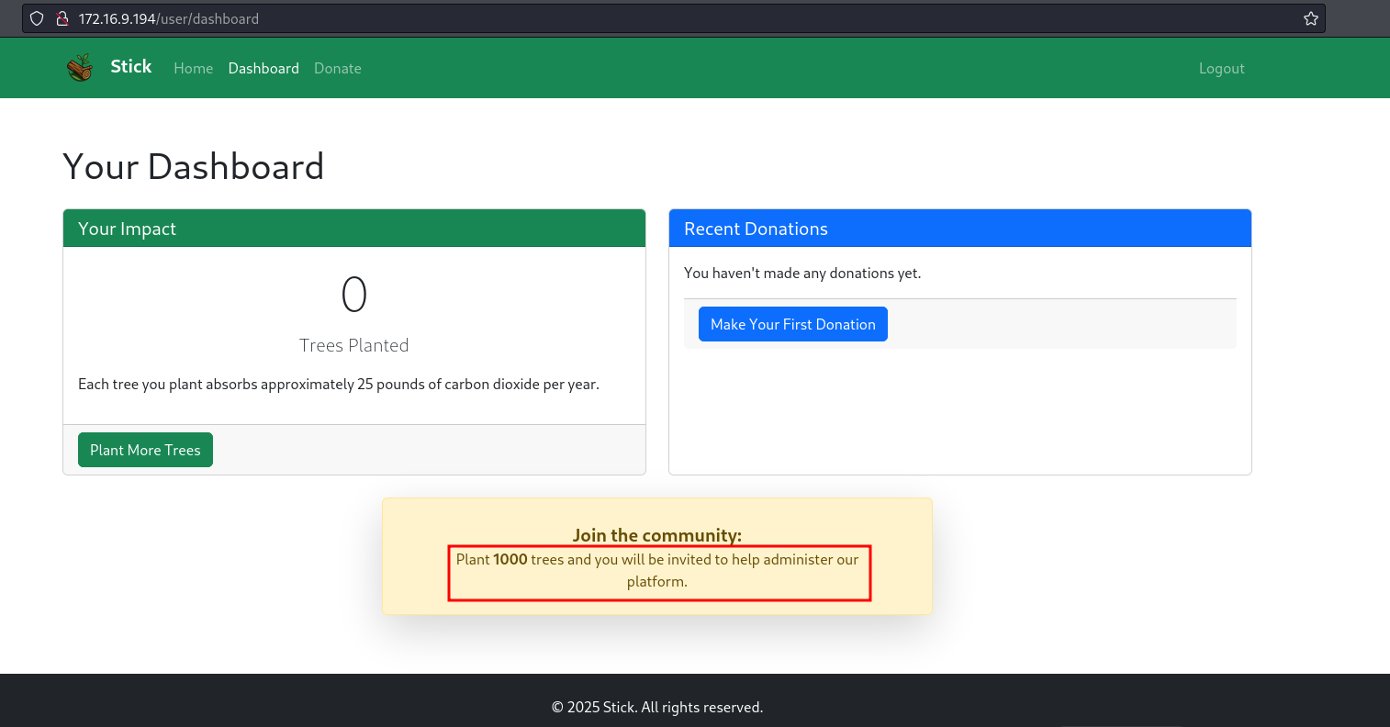
Figure 3 – Dashboard warning message

Exploitation – Obtaining the user flag

When clicking to make a donation, the maximum allowed amount is $100, which corresponds to planting 10 trees.
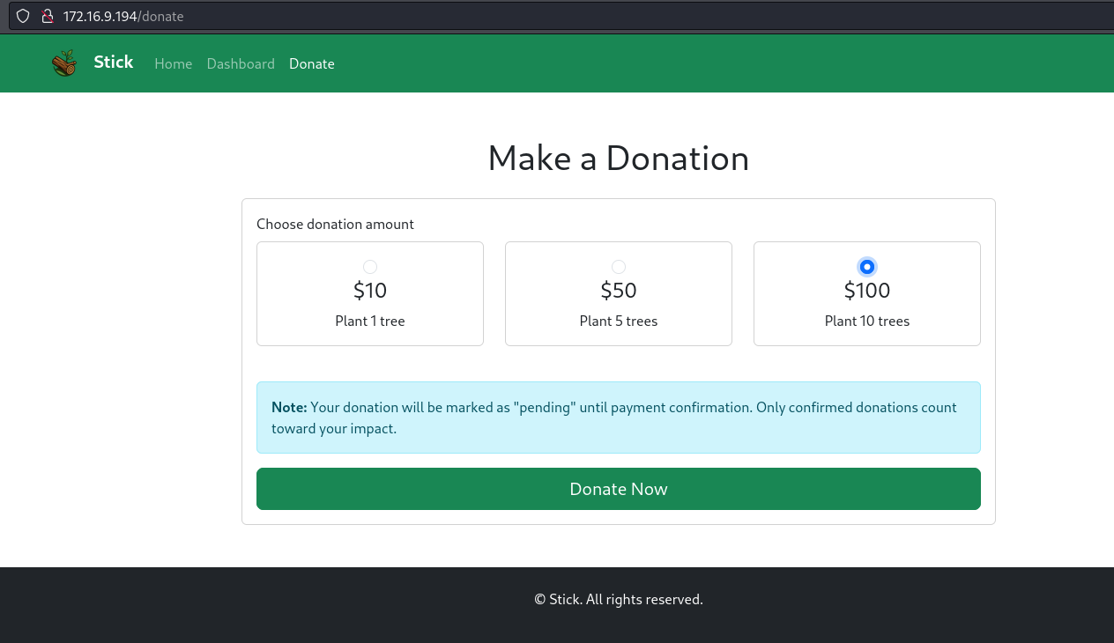
Figure 4 – Donation options

It is possible to intercept the request and increase this value to 10000, which corresponds to 1000 trees.

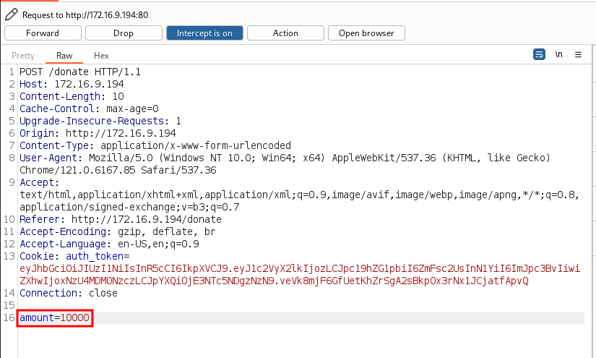
Figure 5 – Modifying the donation amount

However, the donations remain with a pending status.

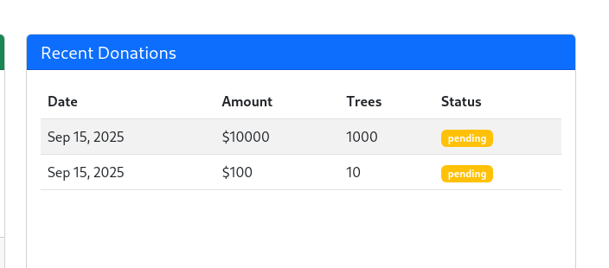
Figure 6 – Donations with pending status

When accessing a donation page and clicking to view the source code, it is possible to observe a function responsible for updating the order status.
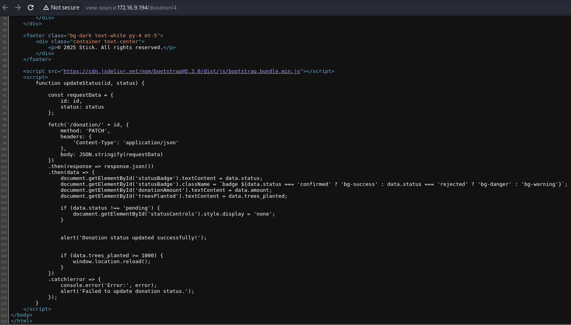
Figure 7 – Function to change status

With this, it is possible to send a PATCH request to the donations endpoint and change the donation status. By sending the request body as shown below, the donation status can be updated.

{"id": 4, "status": "confirmed"}

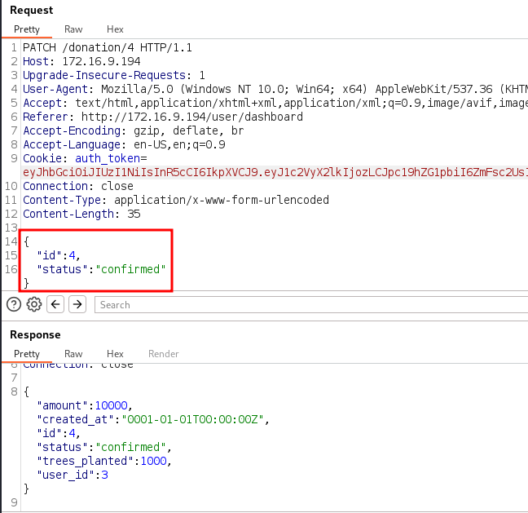
Figure 8 – Changing the donation status

After accessing the donation, it is possible to see that the status has been updated to confirmed.

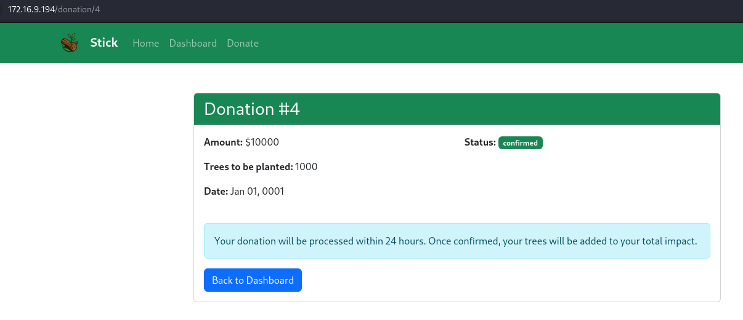
Figure 9 – Donation appears as confirmed

After logging out and logging in again, it is observed that the user can now access the administration panel.

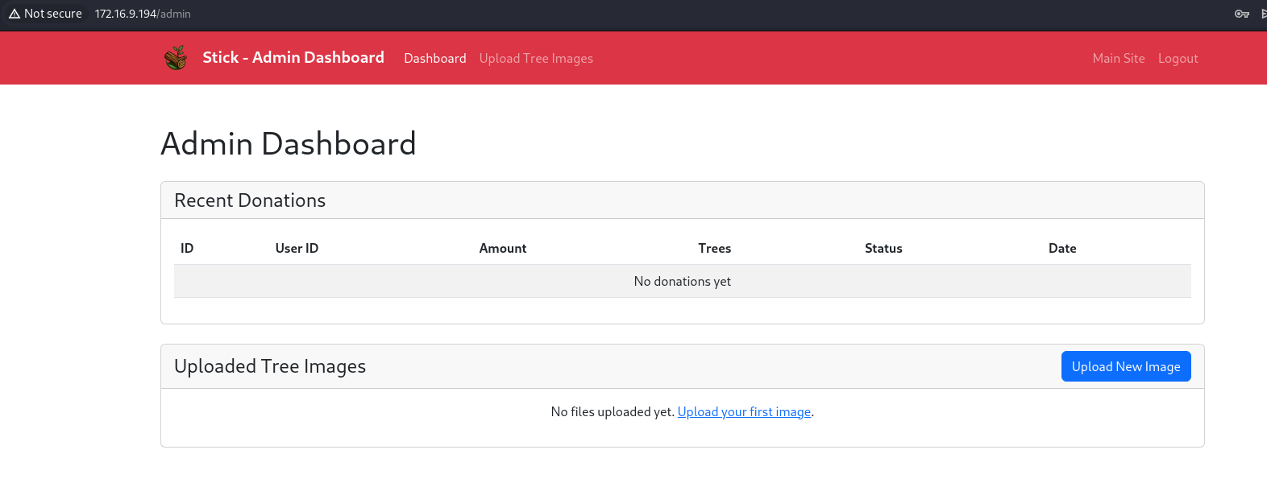
Figure 10 – Administration panel

The administration panel includes an image upload feature. When clicking the button, two image upload options are presented: by file and by URL.

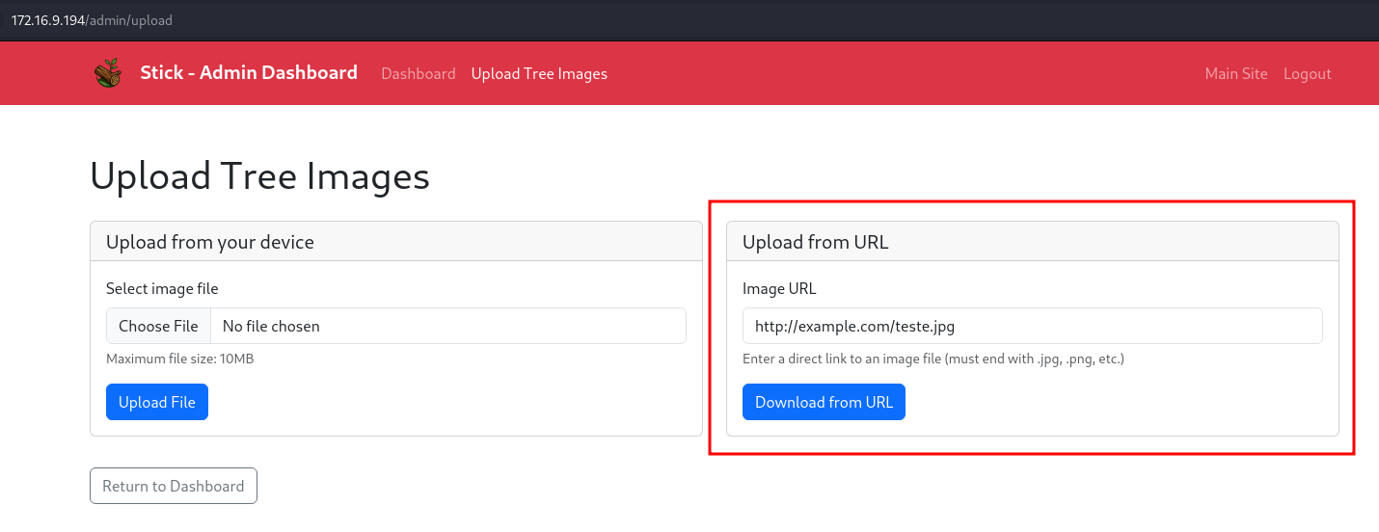
Figure 11 – Image upload functionality via URL

In the URL upload option, intercepting the request shows that the parameter image_url is user-controlled.

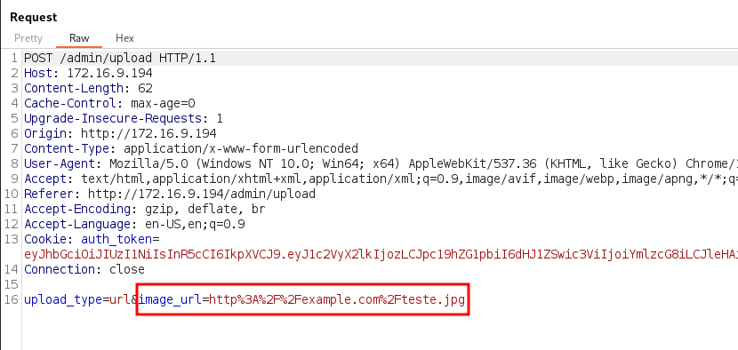
Figure 12 – Image upload via URL parameter

With this, it is possible to exploit an SSRF (Server-Side Request Forgery) vulnerability. By testing some internal server ports, it is possible to identify that Docker port 2375 is open. This allows viewing the running containers using the following URL (URL-encoded):

http://127.0.0.1:2375/containers/json

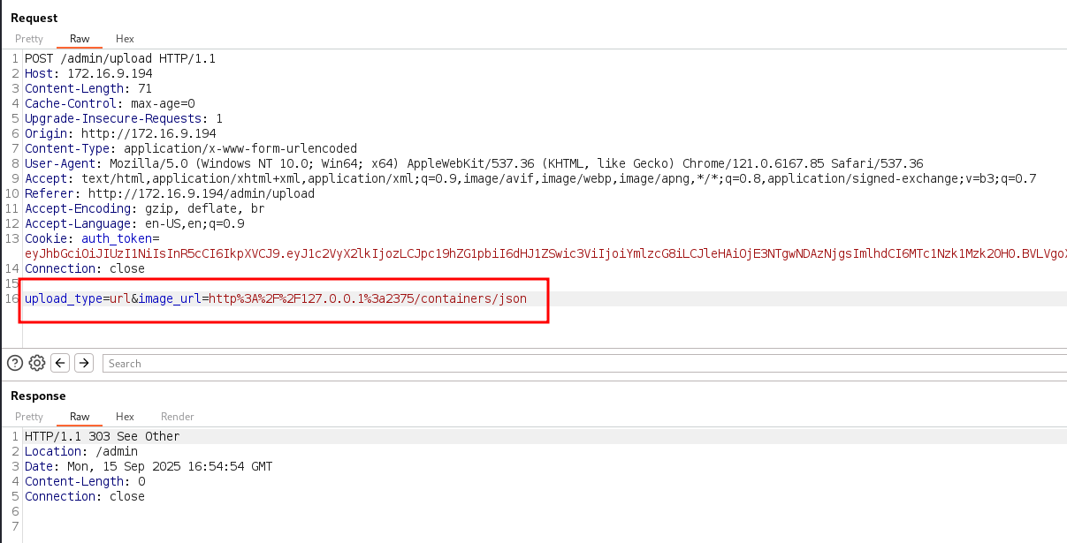
Figure 13 – Using a URL payload to retrieve container information

Returning to the administration panel, it is observed that a card was generated containing the JSON file.

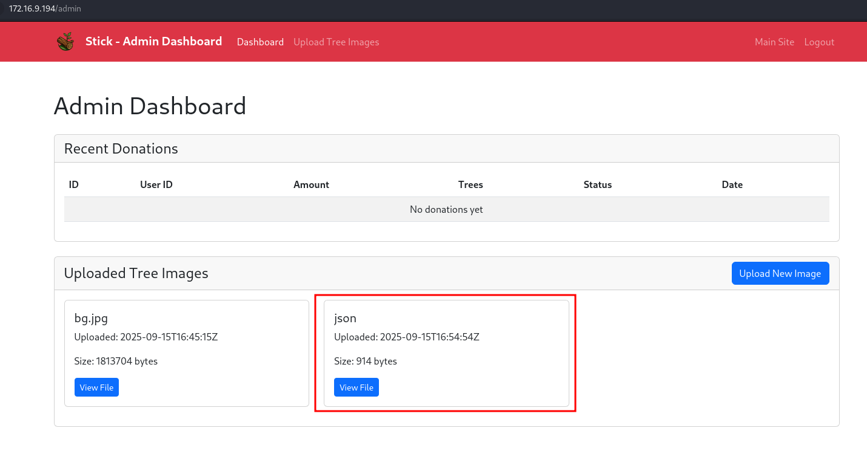
Figure 14 – JSON file generated from SSRF request

By clicking the View File button, it is possible to view information about the containers, including some hard-coded credentials.


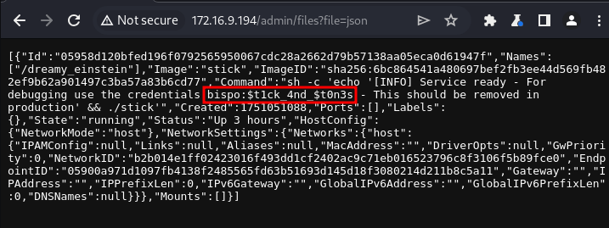
Figure 15 – Hard-coded credentials found in container information

Testing these credentials confirms that they are valid for SSH login.

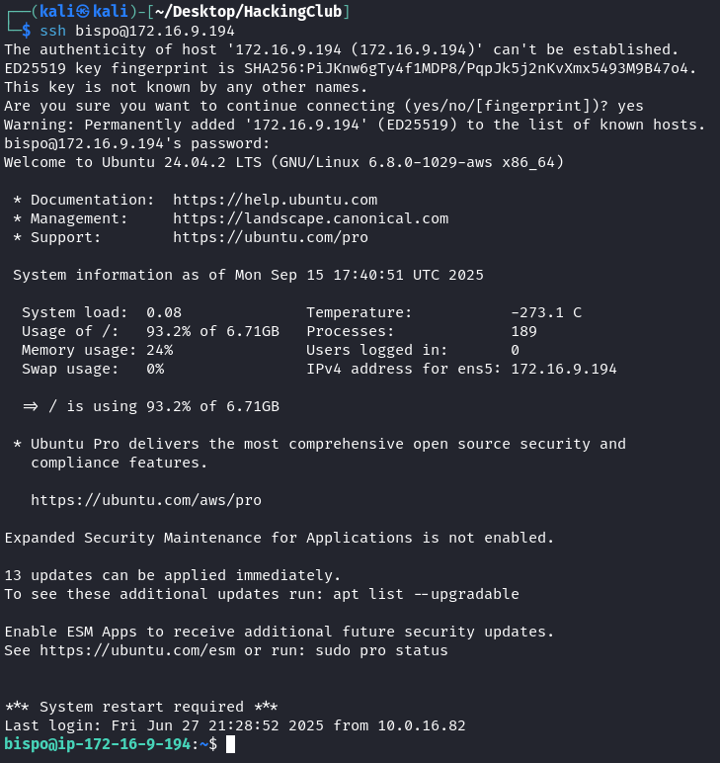
Figure 16 – Accessing the machine via SSH using discovered credentials

After accessing the home directory of the user bispo, it is possible to obtain the user flag.

Figure 17 – User flag obtained

Privilege Escalation – Obtaining the root flag

Enumerating the user bispo using the id command shows that the user belongs to the lxd group, which allows managing containers with lxc in a privileged manner.

Figure 18 – User bispo group enumeration

It is then possible to list the images available on the machine.

lxc image list

Figure 19 – Available image on the machine

Using this image, it is possible to create a container and mount the host’s /root directory inside the container, where the user has full privileges by setting the parameter.

security.privileged=true.

lxc init myimage test -c security.privileged=true
lxc config device add test mydevice disk source=/ path=/mnt/root recursive=true
lxc start test

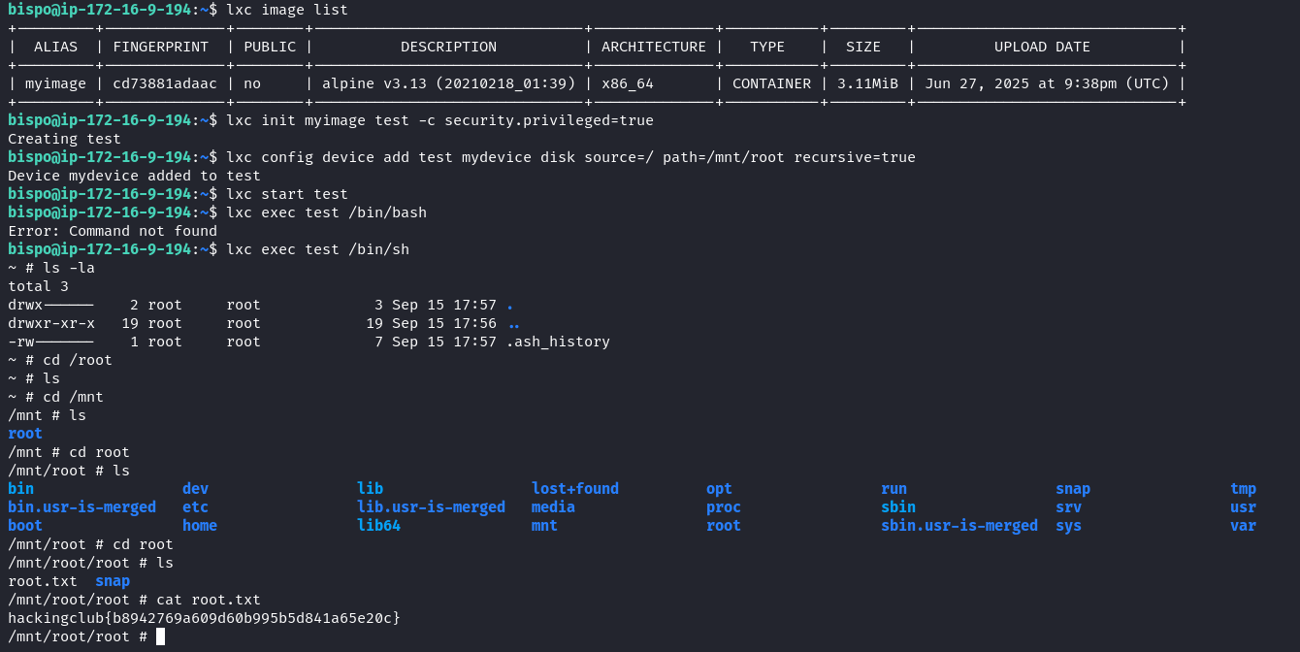
Figure 20 – Creating a privileged container with the host /root directory mounted

Finally, it is possible to access a shell inside the container and read the root flag.

lxc exec test /bin/sh


Figure 21 – Accessing the mounted /root directory inside the container

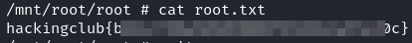
Figure 22 – Reading the root flag

